# title.jpg

# Introduction

Problems with *environmental* *and social dimensions* include deciding where to store radioactive waste, figuring out has rights to water (including how much and the cost), and deciding where to live. These are just a few examples. Any time we build something – a road, a building, a pipeline – there are impacts. GIS and other geospatial tools and technologies can be a great resource and analytical tool in making decisions when you have complex data.

## Assignment Objectives

* Use geographic data and a GIS web app
* Select and pull together complex data
* Use geospatial technologies to help you make a decision
* Apply knowledge gained from this class and critique the usefulness and limitations of your data analysis

This assignment is intended to be open ended. You have complete control over which layers you select and limited control over how your map looks. Use your personal knowledge to select the most appropriate layers for your map.

## Problem

**Where would you want to live if you suddenly were able to choose to relocate to a new city? What criteria would you consider? Can you use a free GIS web app and freely available data to help you decide? Applying what you have learned in this course, do you understand the advantages and limitations of current GIS web apps?**

## Instructions

If you have not already done so, head to arcgis.com and create an account (or sign in with Google or Facebook). Links and instructions can be found in this week’s module.

Once you are logged in, navigate back to arcgis.com and click **Make a Map** (see sample image on next page) so you can create your map and perform your analysis. Please keep a record of your insights and frustrations as you work on this project. It will help with your analysis and writeup. *I recommend making notes on a separate document (such as a Google Doc or an MS Word Doc) as you create your map.*

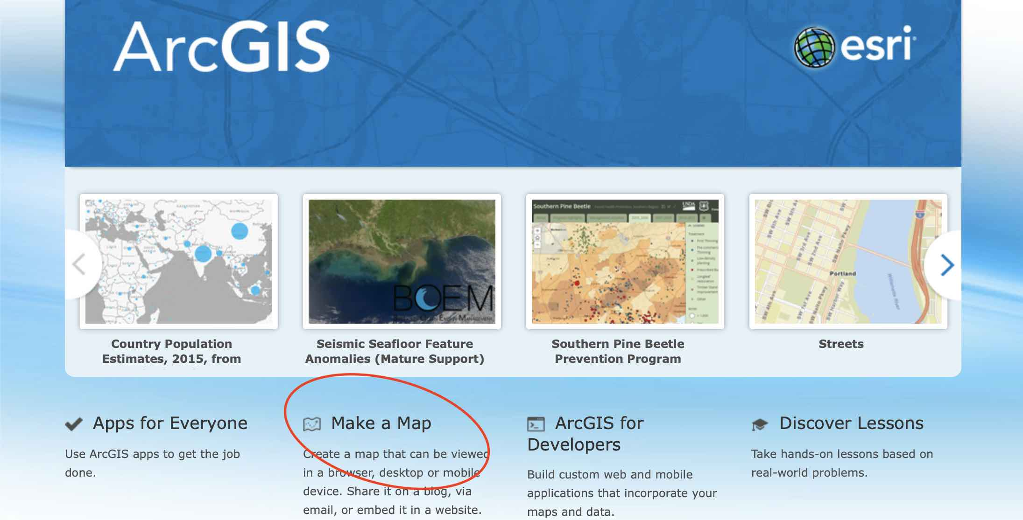

1. Consider the *scale*: How widely will you search? Do you want to look at a major city, a region, a country, or the world? Select your map view accordingly. I found a lot of data was widely available for our populous and economically prosperous state so my map is limited to places within California.
2. Select your **Basemap**. You can change this later if you wish.
3. Select the data layers you would like to consider. This is up to you! **Add** at least four data layers to your map.
   * To search for layers, click **Add** and select your search criteria. I recommend searching **ArcGIS Online**. If you search **My Content** you will probably not return any results, unless you’ve already built up some layers in a GIS class.
   * To read a description of a layer, click on the title of the layer. From the box that pops up, you can select **Add to Map** at the bottom. You can also favorite layers here and you can return to this screen to remove the layer after adding it.
   * Once you’ve added a layer, you can view the *legend* (key) information by clicking **Details**, then **Legend**.
   * If you’re not sure about a layer you’ve just added or if you can’t figure out how to remove one that you no longer want, click **Content**. Check or uncheck boxes to reveal or hide layers that you’ve added. The legend stays up to date; it will only display information for the layers with boxes that are checked.
4. As you make significant progress on your map, please take the time to save your work. Click **Save** and enter a *title*, *tags* (press enter after entering a keyword), and a *summary*. You can probably save with just a title, but you can add tags and a summary to make your map easier to find.
5. Take some time to think about whether there are issues with the data, based on what you have learned in the class. For each layer, or for your overall map:
   * How can you “read” your map to figure out your personalized best places to live?
   * What are the *limitations*? Can you narrow your search to one city or county? Can you make a list of places to check out based on your map? Were you able to find data for all of the areas in the world that might be of interest to you? Was there data that you wanted to include but you could not find?
   * What is the *resolution* of your data and how does this affect your ability to use your map to make decisions?

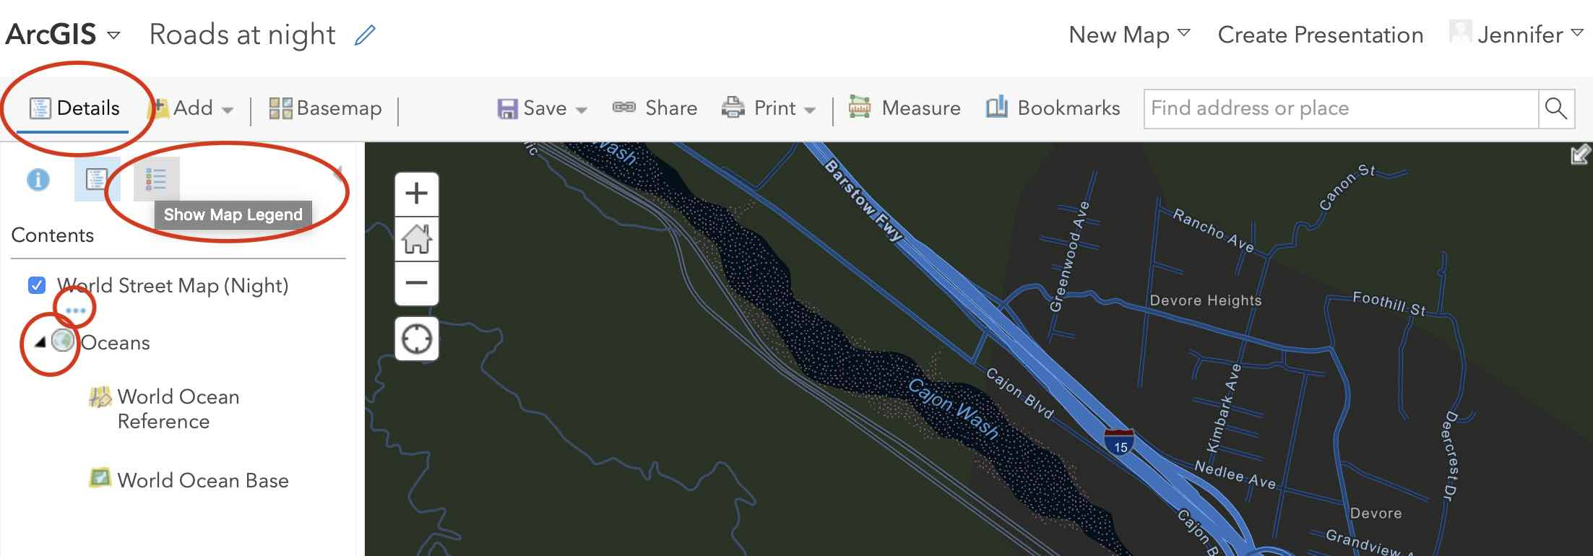

1. If you would like to alter the look of the map, change layers and see if your analysis changes, now is the time to experiment!
   * TIP: Some advanced alterations to the look of the layers can be accessed by clicking **Details**, then **Show map legend.** By expanding the layers in the legend, you can access options. Click arrows to expand layers. If you hover over a layer and see three dots, click those to bring up a menu. **See the red circles on the image above.**
     1. You can alter the **transparency** of each layer to make items more visible or make them fade out, which may help if you want to reveal features of overlapping data.
     2. You can view **details** associated with your layers.
     3. You can also **rename** your layer.
2. When you are finished with your map, print it by selecting **Print** within the ArcGIS web app. Two options appear: Map and Map with Legend. Please select **Map with Legend**. Once your map generates, you can take a **screenshot** or use your browser’s options to “**print**” or **export** a PDF. If this is difficult on your computer, please feel free to take a picture with your phone.
   * TIP: I suggest using at least two different ways to save your map image in case one doesn’t work. Don’t delete your file – keep it in case there is an issue with Canvas.
   * TIP: You may be able to go back and adjust the zoom, however, **I recommend zooming out once before clicking Print (click the “minus sign” one time)**. Usually this will give you the same view on the printable map that you were working with on the previous screen.

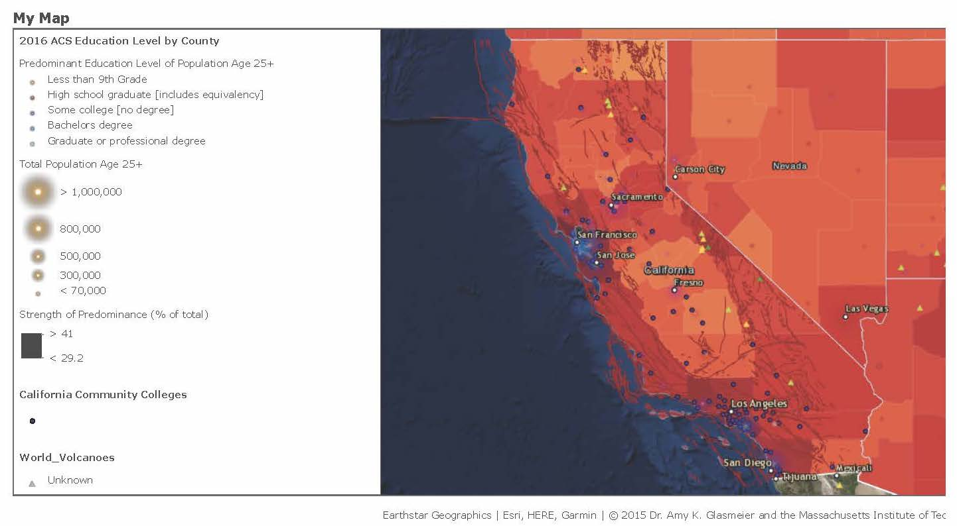

1. On my sample map, the legend is mostly gibberish. I did not take the time to work on cleaning it up or rearranging layers. For the purposes of this assignment, that is okay, but it is a limitation to ArcGIS online. If your legend looks like nonsense, this should be discussed in your write-up.
   * If you are curious about my map, here’s what I considered: Where are the most affordable places with the fewest Ring of Fire hazards (earthquakes, volcanoes) that also have community colleges?
   * If I had to choose where to live and work without considering any additional factors, I would choose to work at one of the community colleges in the middle of the state from Butte College in Oroville to Imperial Valley College in Imperial. I would avoid the colleges near the SoCal fault lines. Of course, in real life the wildfire risk around Butte College makes it less than ideal by my criteria, but that was not easy to add to this already crowded map. It is one of the limitations of my “preliminary analysis” similar to the radioactive waste studies before taking the data to regional and local meetings.

## Write-up

1. **Big Data**: Which data layers did you select and why? Was it easy to add, remove, and edit layers? Did you try to edit the layers or the legend?
2. **Limitations**: What are the limitations of your map? Consider the final product (the map), the data layers, the ArcGIS software/web app, and anything else that you believe is relevant. ArcGIS online is a very limited tool. The Pro software can perform complex analysis, including all types of statistical analysis. The ability to edit maps, images, data, features, attributes, layers, etc. is much more open ended on the Pro version of this software. Please keep that in mind.
3. **Usefulness**: How useful is your map? How can we “read” your map? Based on the layers that you have included, what indicates a “good” place? Does the data give you a good sense of places that you might want to explore if you really had the option or obligation to relocate? What could change about the data, ArcGIS, or other factors that would help you produce a better answer to the problem? What other kinds of data can help with an assignment like this? Is this data available?
4. **Map Analysis**: Based on the map, available data, and limitations of ArcGIS Online, what is your conclusion? Where would you move and why? Did you narrow it down to one place, or a list of places? What is the resolution of your answer, in other words, how far were you able to narrow it down? If you could wave a magic wand and change things so that you could find a perfect answer to the question, “Which place on Earth is best suited to meet my needs and make me happy?”, what would have to change?
5. **Present and Future Applications**: Finally, based on your experience with the software, what are the applications or problem solving abilities of ArcGIS and other GIS software/web apps? How can you see yourself using this type of software to solve problems? What problems would you solve? Would they be personal quests or something you work on for an employer? Think big! The tech world is always evolving. Big Data and artificial intelligence are rapidly evolving and companies that create and use GIS are coming up with solutions to everyday problems all the time.

**Submit your map, write-up, and a link to your map** under the appropriate link in the final module. To ensure you earn points for the link, include it in your write-up and test the link before submitting.